Zewail City of Science, Technology and Innovation
University of Science and Technology
School of Computational Sciences and Artificial Intelligence
CSAI 202 - Fall 2023

CSAI 203 - Fall 2025
Introduction to Software Engineering
<Project Name: Cosmetics Store>
<Report Title: Software Requirements Specification >
Team Number: 09

Team Members:
Rana sherif mohamed - 202401784
Marwa Omar Youssef - 202401652
Mariam Samir - 202200562
Roaa Abdelghany Abdo - 202400980

Software Requirements Specification (SRS)
Project Name: Cosmetics Store
Prepared By: Mariam Samir, Roaa Abdelghany, Marwa Omar, Rana Sherif

1. Introduction

1.1 Purpose
The purpose of this document is to define the Software Requirements Specification (SRS) for the Cosmetics Store, an e-commerce platform that enables users to browse, purchase, and manage cosmetic products efficiently. This document provides a detailed description of system features, user interactions, and operational constraints, serving as a reference for the development team, stakeholders, and testers throughout the software development life cycle.
Expense Tracker web application.
1.2 Scope
The Cosmetics Store system is a web-based application designed to allow customers to shop for cosmetic products online, manage their shopping cart, favorite products, and checkout using cash or credit. Admin users can manage inventory, monitor sales analytics, and process orders.

The system aims to:
- Enable users to browse and purchase cosmetic products efficiently.
- Allow users to manage their cart, favourites, and personal details.
- Support checkout using cash or credit.
- Provide admins with sales analytics, order management, and inventory control.

1.3 Definitions, Acronyms, and Abbreviations
Term | Definition
SRS | Software Requirements Specification
UI | User Interface
UX | User Experience
DB | Database
Cosmetics Store | The proposed e-commerce platform for cosmetic products
User | Customer purchasing cosmetic products
Admin | Administrator managing inventory and sales
Cart | Temporary storage for products selected for purchase
Order | Purchase made by a user
Checkout | Process of finalizing a purchase
Rating | User review and score of a product

1.4 References
- IEEE Std 830-1998 – IEEE Recommended Practice for Software Requirements Specifications
- Course Project Guidelines – CSAI 203: Introduction to Software Engineering, Fall 2025
- Project Repository Documentation (GitHub)
- E-commerce UX & Security Standards

1.5 Overview
This document outlines the purpose, scope, and functionality of the Cosmetics Store system. Subsequent sections describe:
- System features and user requirements
- Functional and non-functional requirements
- System design diagrams and conceptual class diagrams

2. Overall Description

2.1 Product Perspective
The Cosmetics Store is a standalone e-commerce application with a client-server architecture:

- Frontend: HTML, CSS, JavaScript, responsive design for web and mobile.
- Backend: Flask (Python) handles business logic, authentication, orders, and analytics.
- Database: MySQL or SQLite storing users, products, orders, and reviews.

Components:
- Frontend: User-friendly interface for browsing, cart management, and checkout.
- Backend: Handles logic, database communication, and admin analytics.
- Database: Stores product catalog, orders, user data, and reviews.

2.2 Product Functions
- User Registration & Authentication
- Register, login, logout, manage profile
- Product & Cart Management
- Add/delete products to/from cart, search products, add to favorites
- Checkout
- Add address and phone, pay via cash or credit
- Product Ratings
- Users can rate purchased products
- Admin Management
- Inventory overview, manage products, low stock alerts
- Order management: Pending, Processing, Completed, Cancelled
- Sales analytics with reports and charts

2.3 User Classes and Characteristics
User Type | Description | Characteristics / Permissions
Customer | Purchases products | Register/login, add to cart, checkout, rate products, manage favorites, view order history
Admin | Manages store | View sales analytics, manage orders, manage products, monitor inventory

User Characteristics:
- Users are expected to have basic computer and internet literacy.
- No specialized knowledge is required.
- The interface is designed to be intuitive and user-friendly.

2.4 Operating Environment
- Client:
Modern web browsers, responsive design.
- Server:
Flask on Windows/Linux Server.
- Database:
MySQL or SQLite.
- Hosting:
Cloud-based deployment.

2.5 Design and Implementation Constraints
- The system must be implemented using Flask (Python) for backend development.
- The frontend must be developed using HTML and CSS (with optional JavaScript).
- The system must store data in a relational database (MySQL or SQLite).
- The application must support cross-browser compatibility.
- Security constraints include encrypted password storage and protected routes for authenticated users.
- Performance constraints include handling up to 100 concurrent users efficiently.
- The user interface must adapt to both desktop and mobile screen sizes (responsive design).
- The export and reporting features must comply with data format standards (PDF/XLSX).

2.6 User Documentation
The following documentation will be provided to guide users:
- User Manual: Step-by-step instructions for shopping, checkout, and profile management.

2.7 Assumptions and Dependencies
Assumptions:
- Users will have stable internet access and a modern web browser.
- Users will provide accurate financial information for analysis.
- The system will operate on standard web infrastructure with moderate traffic.
- The application will be maintained by a small development team.
Dependencies:
- Flask (Python Framework) for backend operations.
- HTML/CSS/JavaScript for frontend design.
- MySQL or SQLite as the database management system.
- Chart.js / Recharts for data visualization.
- jsPDF / ExcelJS for exporting reports.
- External email or notification services for sending alerts.

3. Specific Requirements
- 3.1 Functional Requirements
The following list defines the system’s main functional requirements, describing what the system must do.

FR-1: User Registration and Authentication
- The system shall allow users to register with a unique email and password.
- The system shall validate login credentials and provide access based on authentication status.
- The system shall encrypt user passwords for secure storage.
- The system shall allow users to reset forgotten passwords via email verification.

FR-2: Product & Cart Management
- The system shall allow users to browse products by name, category, or price.
- The system shall allow users to add or remove products from their shopping cart.
- The system shall allow users to add or remove products from their favorite list.
- The system shall display the current total of products in the cart.

FR-3: Checkout (Cash/Credit)
- The system shall allow users to provide a valid address and phone number for delivery.
- The system shall allow users to pay using cash on delivery or credit cards.
- The system shall display an order summary before finalizing the checkout.
- The system shall confirm the order and notify the user via email.

FR-4: Ratings and Favorites
- The system shall allow users to rate purchased products.
- The system shall allow users to leave optional comments with ratings.
- The system shall display average product ratings for each product.
- The system shall allow users to manage their list of favorite products.

FR-5: Admin Management (Inventory, Orders, Analytics)
- The system shall allow admins to add, edit, or delete products.
- The system shall alert admins when product stock is low.
- The system shall allow admins to update order statuses (Pending, Processing, Completed, Cancelled).
- The system shall allow admins to view sales analytics and generate reports.

3.2 Use Case Model

3.2.1 Use Case Diagram
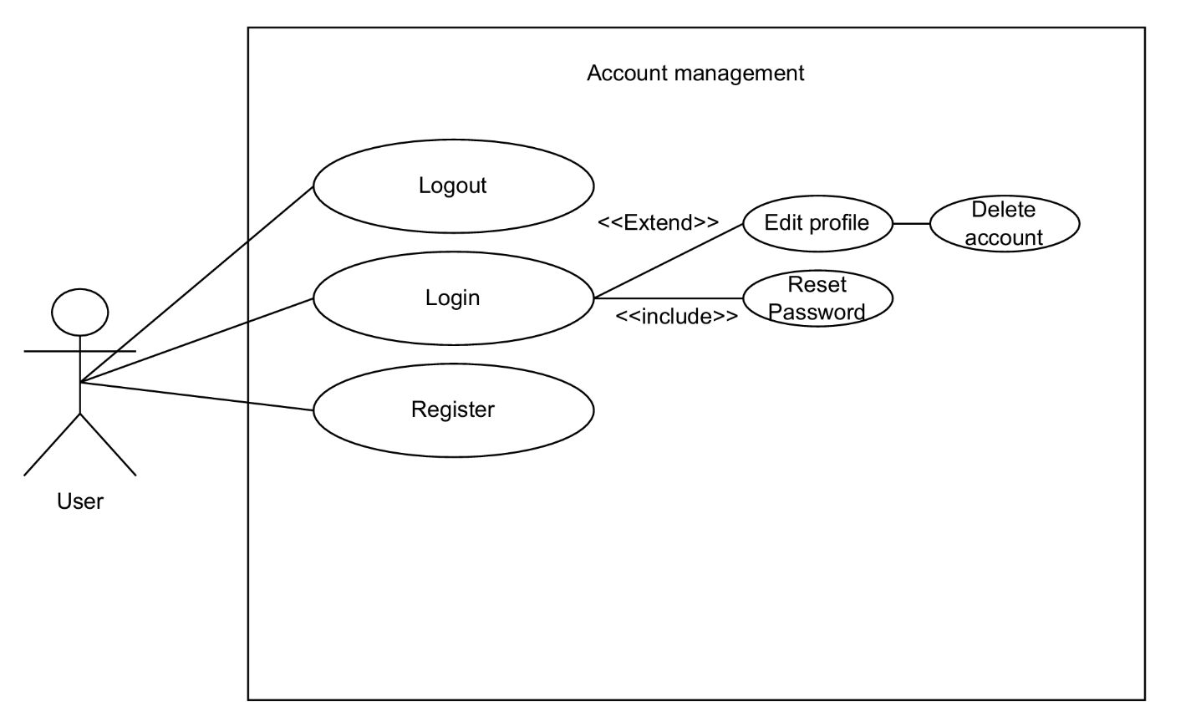
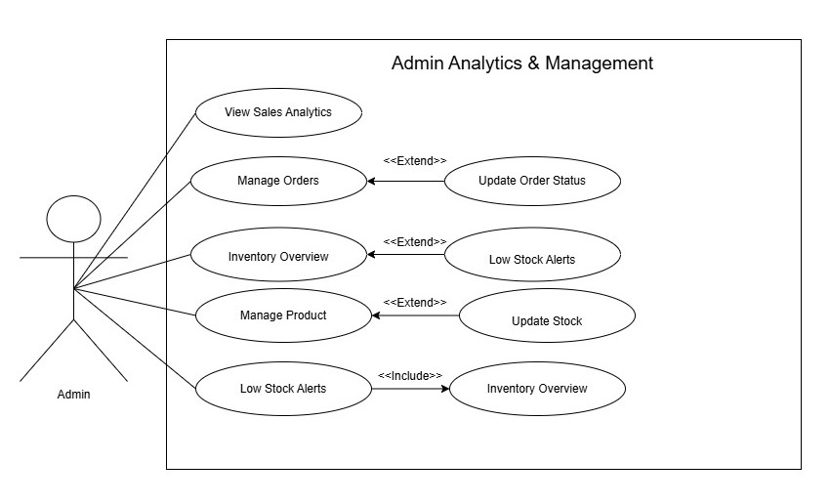

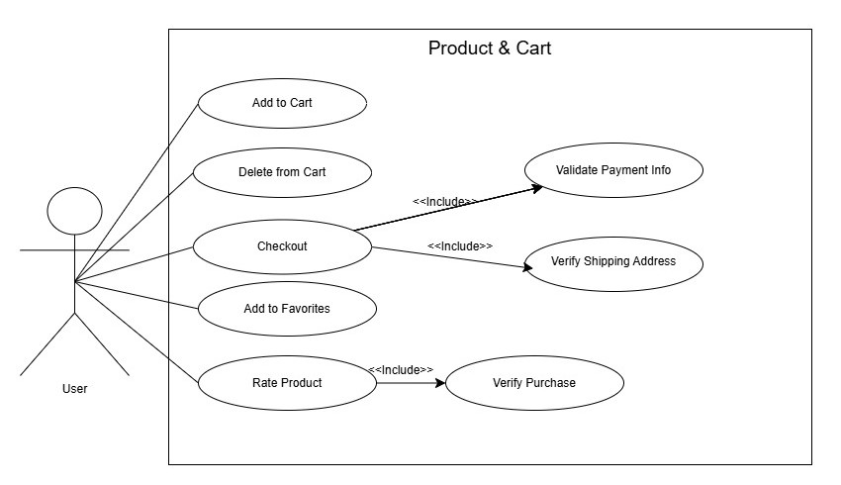

3.2.2 Use Case Descriptions (Account Management)
Use  Case ID | Use Case Name | Actors | Description | Preconditions | Postconditions
UC-01 | Register | User | Allows a new user to create an account by providing required details (name, email, password) | Internet access, registration page | User account stored in the database, ready for login.
UC-02 | Login | User | Enables a registered user to log in using valid credentials. | User must already be registered | User session is created; dashboard accessible.
UC-03 | Logout | User | Allows the user to securely log out of the system. | User must be logged in | User session terminated; redirected to login page.
UC-04 | Edit Profile | User | Allows the user to update personal details such as name, email, phone. | User must be logged in | Updated profile information saved in the database.
UC-05 | Reset Password | User | Enables user to reset password via email verification or security code. | User must have a registered email | Password updated; user can log in with the new password.
UC-06 | Delete Account | User | Allows user to permanently delete their account along with all associated data (orders, favorites, reviews). | User must be logged in | User account and all related data are removed from the database.

3.2.2 Use Case Descriptions (Product & Cart Management)
Use  Case ID | Use Case Name | Actors | Description | Preconditions | Postconditions
UC-01 | Browse Products | User | User can view all available products, search by name or category, and filter by price or brand. | Internet access | Product list displayed with search and filter applied.
UC-02 | Add to Cart | User | Allows user to select products and add them to their shopping cart. | User logged in; product exists | Product added to cart; cart updated in database.
UC-03 | Delete from Cart | User | Allows user to remove one or multiple products from their cart. | Product exists in cart | Product removed from cart; cart updated in database.
UC-04 | Checkout | User | User finalizes purchase by providing shipping details and selecting payment method (cash/credit). | Cart not empty; user logged in | Order stored in database; inventory updated; confirmation sent to user.
UC-05 | Add to Favorites | User | Allows user to save products to their favorite list for future purchases. | User logged in | Product saved in favorites; database updated.
UC-06 | Rate Product | User | User can rate and provide a review for products they purchased. | Product purchased by user | Review and rating stored; visible on product page.
UC-07 | Search Products | User | User can search products by name, brand, or category using keywords. | Internet access | Relevant products displayed in search results.
UC-08 | View Product Details | User | User can view detailed information about a product including price, description, stock, and reviews | Product exists in database | Product detail page displayed.

3.2.2 Use Case Descriptions (Admin Management)
Use  Case ID | Use Case Name | Actors | Description | Preconditions | Postconditions
UC-01 | Login | Admin | Allows admin to log in to the admin panel using credentials. | Admin registered. | Admin session created; access granted to dashboard.
UC-02 | Manage Products | Admin | Admin can add, edit, or delete cosmetic products, including details like name, category, price, stock, and image. | Admin logged in. | Product database updated; changes reflected on user side.
UC-03 | Inventory Overview | Admin | View current stock levels, total products, and low-stock items. | Admin logged in; products exist. | Inventory dashboard displayed; low-stock items highlighted.
UC-04 | Low Stock Alerts | Admin | System notifies admin when products fall below a defined threshold. | Inventory exists. | Alerts displayed; admin can take action (restock).
UC-05 | Manage Orders | Admin | Admin can view all orders, update status (Pending, Processing, Completed, Cancelled), and process returns or cancellations. | Orders exist. | Order status updated; notifications sent to user.
UC-06 | View Sales Analytics | Admin | Admin can generate reports and charts to analyze sales, revenue, best-selling products, and monthly trends. | Admin logged in; orders exist. | Analytics displayed on dashboard; exportable to PDF/Excel.
UC-07 | Manage Users | Admin | Admin can view registered users, deactivate accounts, or assist with account recovery. | Admin logged in; users exist. | User information updated; actions logged in system.

3.3 Domain Model
3.3.1 Conceptual Class Diagram

3.3.2 Class Diagram
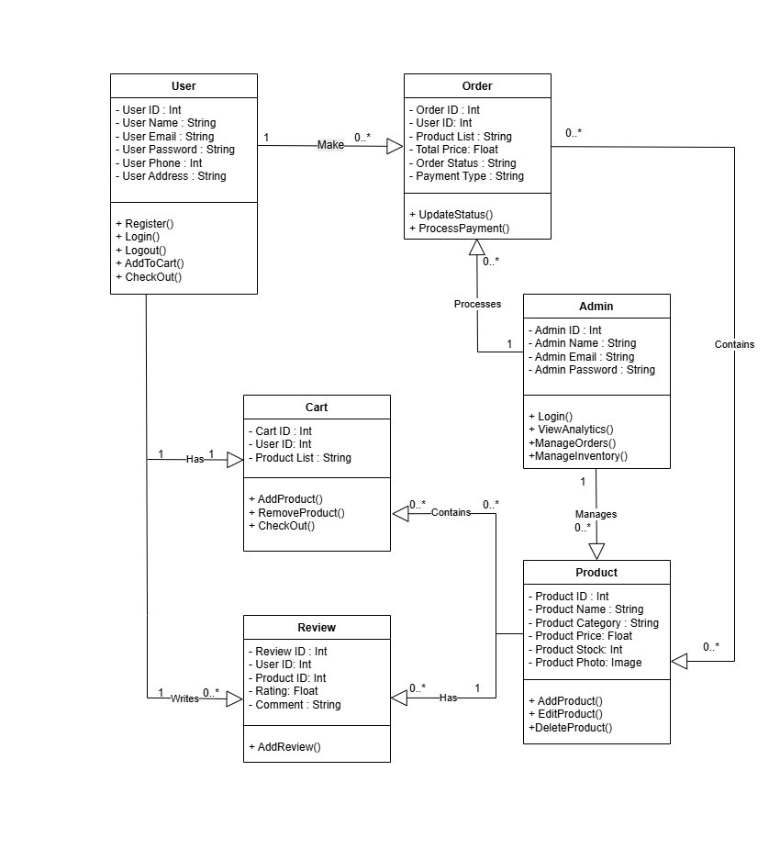

3.3.3 Class Descriptions
Class Name | Description | Attributes | Methods | Relationships
User | Customer purchasing products | User_id, name, email, password, phone, address | register(), login(), logout(),AddToCart(), checkout() | One-to-many with Order, One-to-many with Review, One-to-one with Cart
Admin | Store manager | admin_id, name, email, password | login(), viewAnalytics(), manageOrders(), manageInventory() | One-to-many with Product, Order
Product | Cosmetic product | product_id, name, category, price, stock, photo | addProduct(), editProduct(), deleteProduct() | Many-to-many with Cart, One-to-many with Review
Cart | User cart | cart_id, user_id, product_list | addProduct(), removeProduct(), checkout() | One-to-one with User, Many-to-many with Product
Order | Purchase record | order_id, user_id, product_list, total, status, payment_type | updateStatus(), processPayment() | Many-to-one with User, Many-to-many with Produc
Review | Product rating | review_id, user_id, product_id, rating, comment | addReview() | Many-to-one with Product, Many-to-one with User

